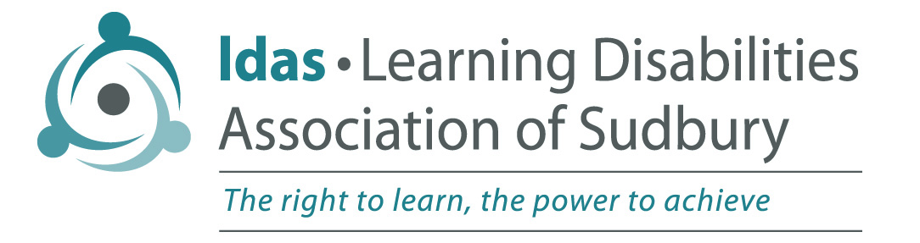

Mailing address: PO Box 40012, 2015 Long Lake Road, Sudbury, ON, P3E 0B2
Office location: Lockerby Composite School, 1391 Ramsey View Ct.
Tel: (705) 522-0100 / Fax: (705) 522-2289
resource@ldasudbury.ca / www.ldasudbury.ca

Registration Form 2022

1. Student Information (please print)
First Name |  |  |  | Last Name |  |  | - Male Female |  |  | - Prefer not to Disclose
Grade |  |  |  | Name of School
2. Parent/Guardian Information
Name |  |  |  |  |  | Relationship to Child
Address
# and Street Apt # (if applicable) Town, Province Postal Code
Telephone (home)  (work) |  |  |  |  |  | May we contact you at work?
 |  |  |  |  |  | - Yes |  |  | - No
Email

3. Identification of Learning Disability
Has your child been assessed as having a learning disability?
- Yes | - No
If “Yes”, when and by whom?

Does your child have an I.E.P. (Individual Education Plan)?
❑ Yes  No

If yes, please give date of most current I.E.P. _________________________________

4. Diagnosis of ADHD
When was your child diagnosed as having ADHD?

/ /  Year/ Month/ Day |  |  | Please indicate type of ADHD  Hyperactive/Impulsive Inattentive Combined Subtype Unknown
Is your child on any medication for behaviour modification?
- Yes  No

5. Other Exceptionalities
Has your child ever been assessed as having any other exceptionality? i.e. ODD, OCD
❑ Yes  No
If yes, please describe.

PAGE 1 of 2 (please turn page over)

6. Major Parental Concerns
I
Include a brief description of the major concerns you would like help with regarding your child.

7. School Assistance and Family Treatment Histories
Include a brief history of previous school assistance for your child and any family assistance/treatment.

8. Responsibility
Parents are encouraged to attend all 10 virtual sessions of the program.

Parents are encouraged to complete a survey at the end of each session to assist with future program planning and development.

Signature of Participant Date

LDA Sudbury works in compliance with the Personal Information Protection and Electronic Documents Act (PIPEDA) and will only use the information collected for its intended purpose. This information is collected for the LDAS Student Coaching Program.

